Modular System

In this document the basic weapon and modular system is explained. This gives an overview on the rock-paper-scissor combat system as well how we use the modules in different systems.

Final delivery date: Week 8

Feature status (Y/N):
Initial design | Y
Prototyped/tested | Y
Approved by design lead | Y
Approved by tech lead
In development
Art complete
Audio complete
Final polish
Finalized

People working on it: Kuba Kuleszewicz, Floyd Krielaart, Dana van der Wal

CHANGELOG
No. | Date | Developer | Description
001 | 03/12/2018 | Floyd Krielaart, Dana van der wal | Defines how the modular system will work for weapons and the suit.
002 | 04/12/2018 | Kuba Kuleszewicz | Added “Visuals” section
003 | 11/12/18 | Dana van der Wal | Modelar system, tool, suit, drone and other

Feature design
Why
Modular system:

Combat rock-paper-scissors:
The rock-paper-scissor combat has been used successfully in many games. We choose for this system to present a strategic challenge to the player.

What is the minimum viable version:

What is the feature:

How does it work?
Each object that can use the modules will be able to gain various effects from them depending on which modules and how many of each one you have slotted in.
Below is a chart with all the possible combinations of modules, and in what categories they fit.
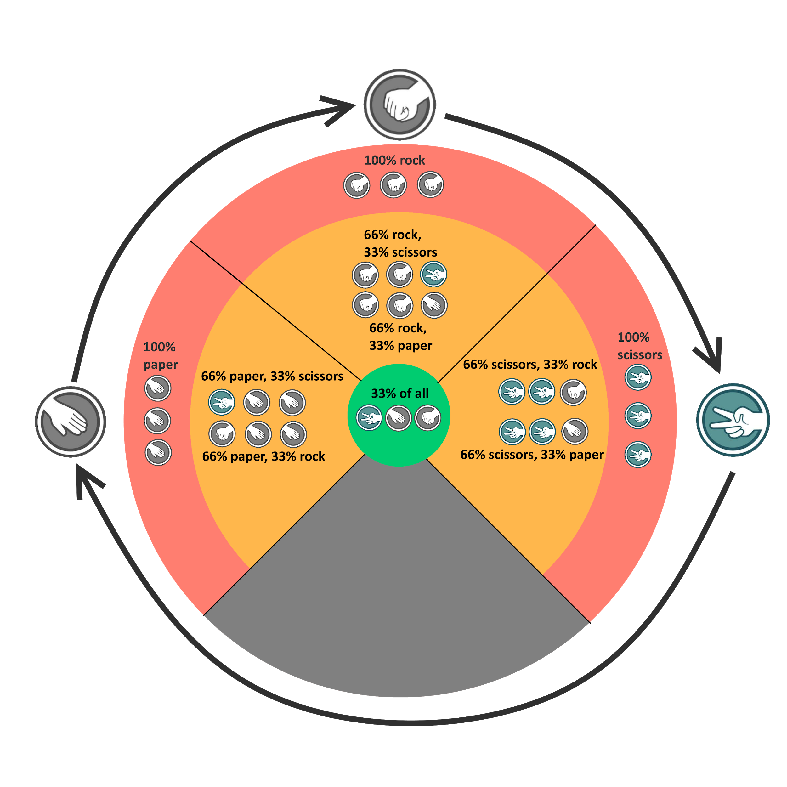

How does it work for different systems?

Weapons and armour: Strengths
The weapons will use the modules in a system that will allow them to specialize against certain types, similar to a normal game of rock paper scissors in real life. You can have 3 modules in your gun such as the following combination below
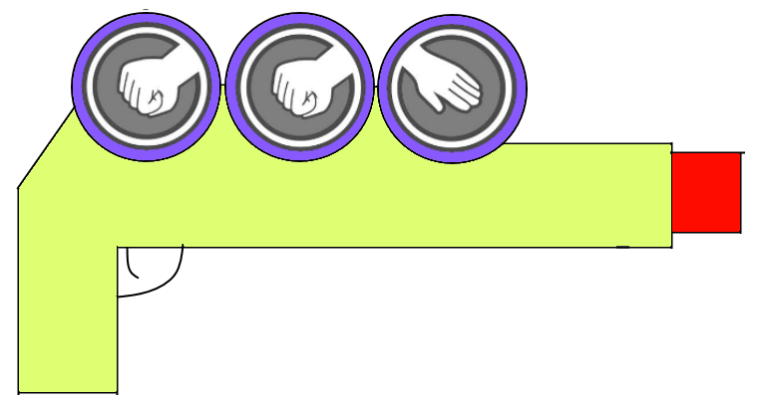
This potential setup shows 2 rock and 1 paper module. Which would cause it to cause for example 40 rock damage and 20 paper damage. This damage is then handled by the enemy. Let's say the enemy is a scissor type enemy, and thus they are weak to rock. This doubles the damage they take from rock. Which means they take 80 damage. However, they are strong against paper which halves the damage, this results in the paper damage being 10. This means the enemy takes 90 damage in total.
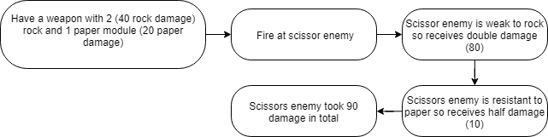
This system would allow us to introduce a large amount of variety in the enemies by re-using the same NPCs with different variations and reinforce players to use a variety of weapons.
This same system applies to the player’s armour; the enemies also use similar weapons to you and will use them to try and kill you. You can put modules in your armour to gain resistance against specific modules. For example, if you have 3 rock modules on your armour and someone fires a gun with scissor modules at you, you would take a lot less damage than normal.

Weapon behaviour
https://drive.google.com/open?id=17yPjm8MnAHzwegiLp9eGziSnNdbLNGHJB96NpA2aNq8

Tool:
How do the modules work for the tool?

Suit:
How do the modules work for the tool?

Drones:
https://drive.google.com/open?id=1jRmuqDNzgIWoDogGHoDePuSo6kUu9loW06gGz34wtLo

Optional:
- Crafting:
- Torrents/traps: same as weapon system:
- Movement:
- On core of the base/energy output:

Technical Design:
- Players should be able to add an amount of modules to a variety of objects (Weapons, armor, turrets, etc) which should affect the behavior of those objects.
- Each type of object should have different calculations for modules:
Weapons:
Different weapons are created for different modules used, each weapon then has an amount of rock, paper and scissor damage (Set by the designer). How that damage is handled by enemies can be seen in the Armor section.
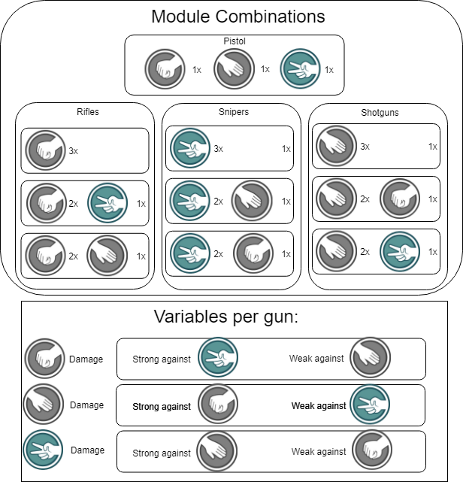

Enemy Armor:
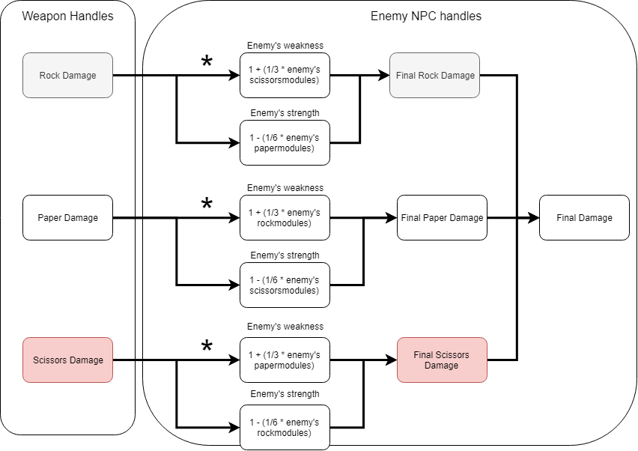

Audio requirements:

Art requirements:

Weapon constraints
- Hitscan
- Infinite ammo - overheating system
- Modular modification system
  - 3 types of modules:
    - Fire Rate
    - Area of effect
    - Shorter cooldown (?)
  - Start with a balanced set
  - Modules of the same type are interchangeable/indistinguishable
  - New module replaces an old one
  - Acquired from enemies/drones
  - Non-craftable
  - All slots have to be filled out

Conclusions:
- The player doesn't make it himself → Should be high-tech
- Parts are interchangeable → They can’t be a specific part, like a barrel or a slide
- Overheat system → can be either positive or negative
  - Positive - you’re getting to much bad stuff, for example, heat
  - Negative - you’re running out of a renewable resource, for example, battery

Possible technologies for base of the weapon

Light
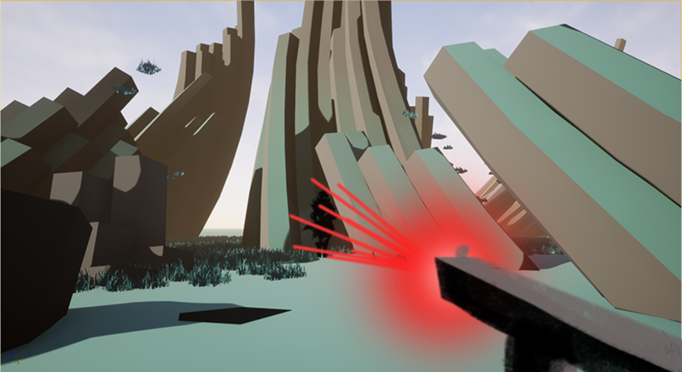
What is it: Laser beam
How it causes damage: Burning
What’s the cooldown: Power source capacity (battery, crystal?)
What are the modules: Lenses, filters

Electricity, lightning
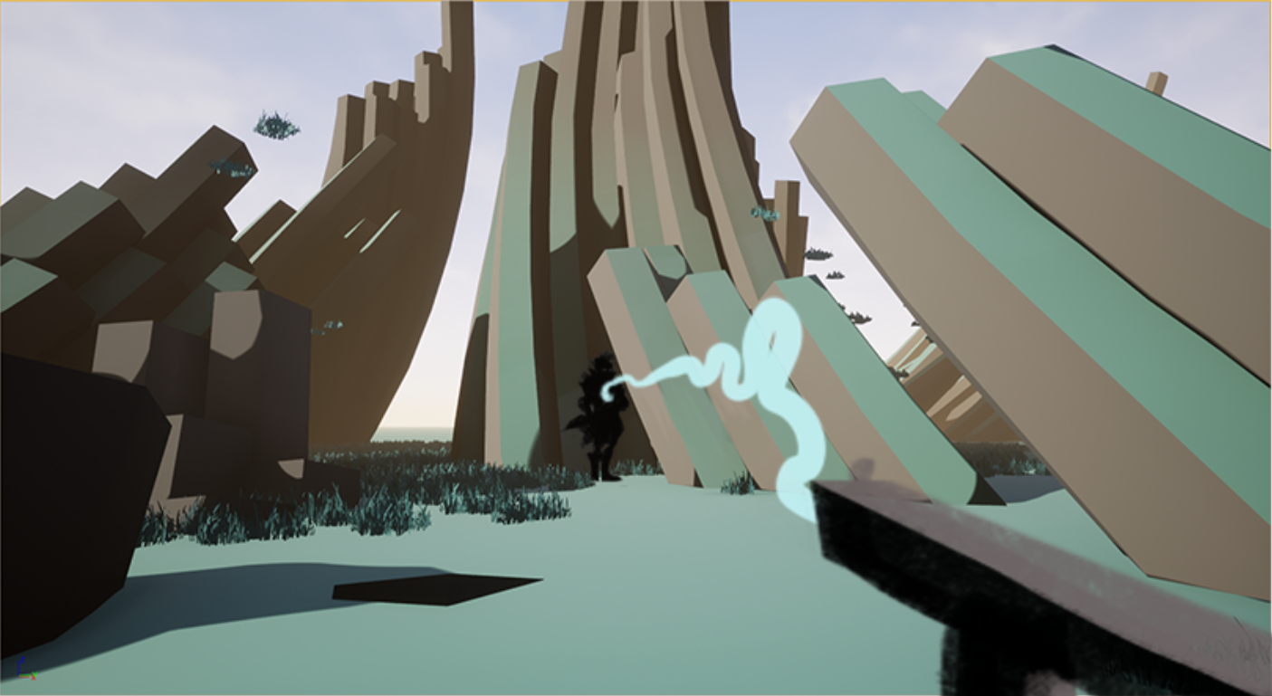
What is it: Tesla coil
How it causes damage: Burning, electrocution
What’s the cooldown: Power source capacity (battery, crystal?)
What are the modules: Electronics, capacitors, resistors, diodes

Waterjet
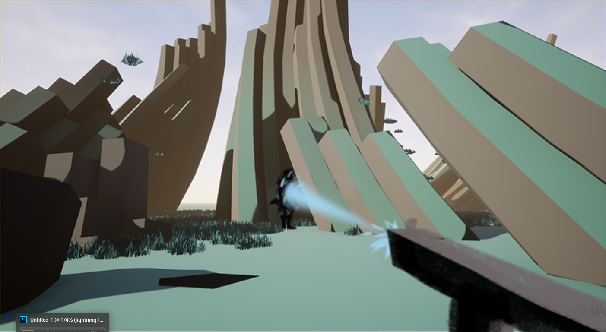
What is it: Water cutter, hose
How it causes damage: Water is poisonous/corrosive to this planet's organisms?
What’s the cooldown: ?
What are the modules: Valves, filters, nozzles

Environment projectiles
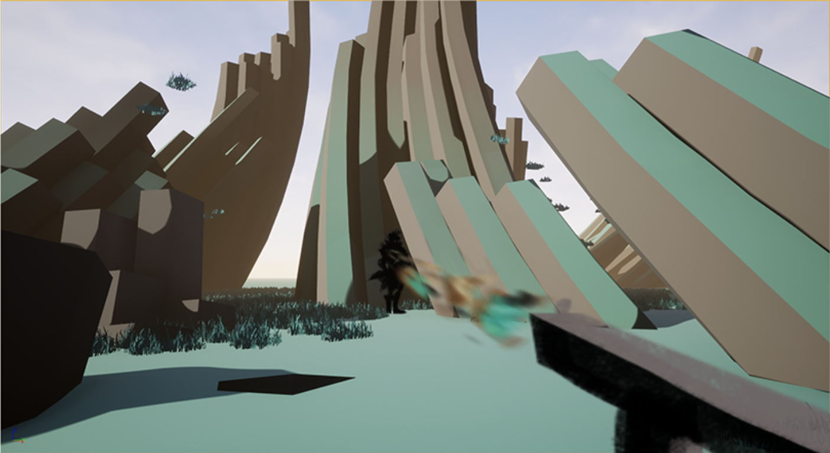
What is it: Air blower, throws rocks, sand, ect.?
How it causes damage: Physical impact
What’s the cooldown: Clogging up?
What are the modules: Filters for different objects

Sound waves
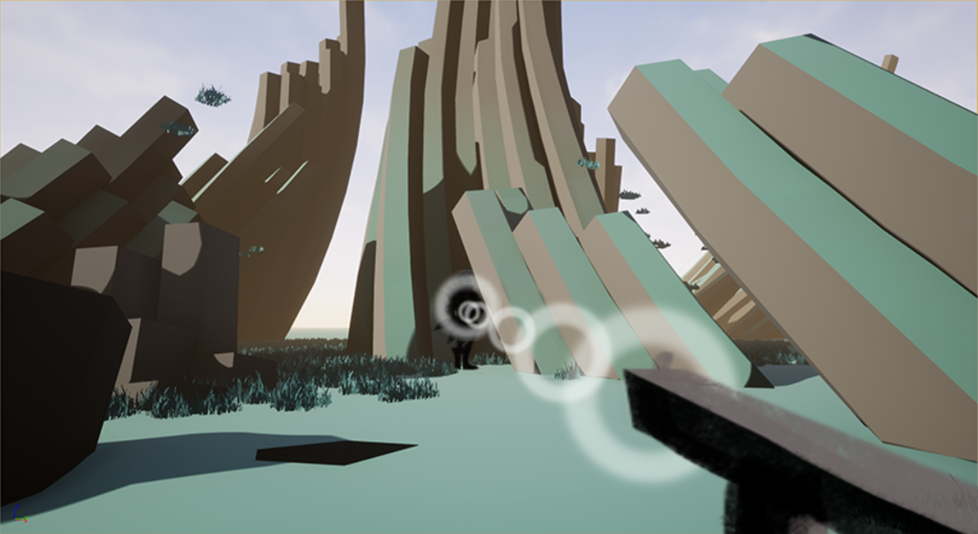
What is it: A giant speaker
How it causes damage: Air pressure, sound waves
What’s the cooldown: Power source capacity (battery, crystal?), overshaking?
What are the modules: Tubes, speakers

Bending gravity
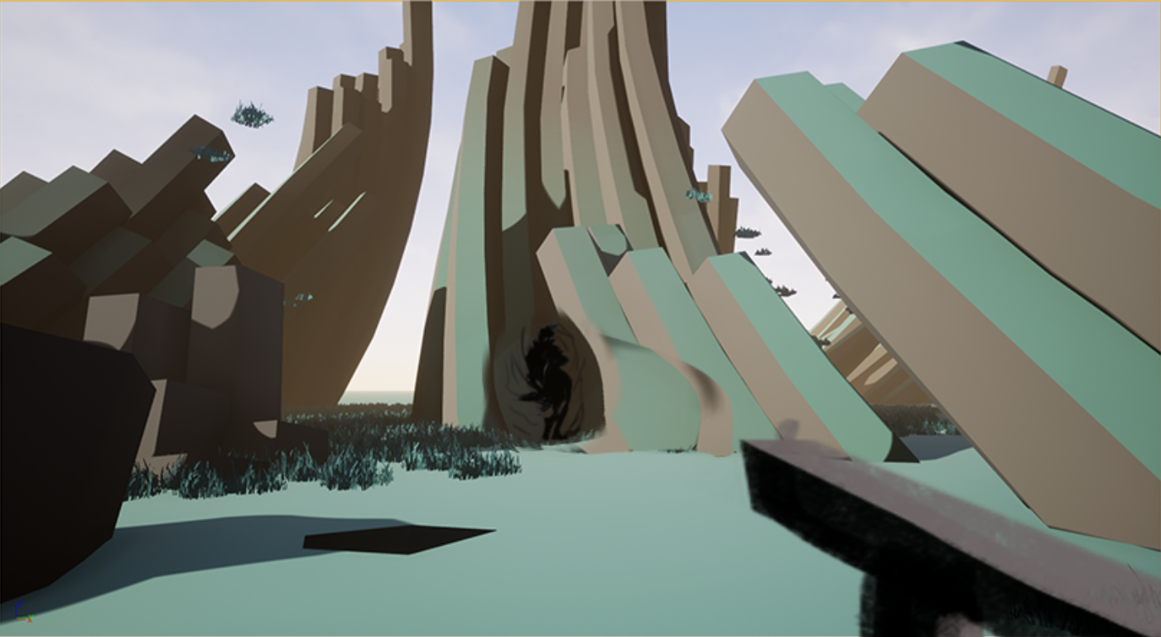
What is it: Gravity bender?
How it causes damage: Spaghettification
What’s the cooldown: Power source capacity (battery, crystal?)
What are the modules: ?

Speeding up time
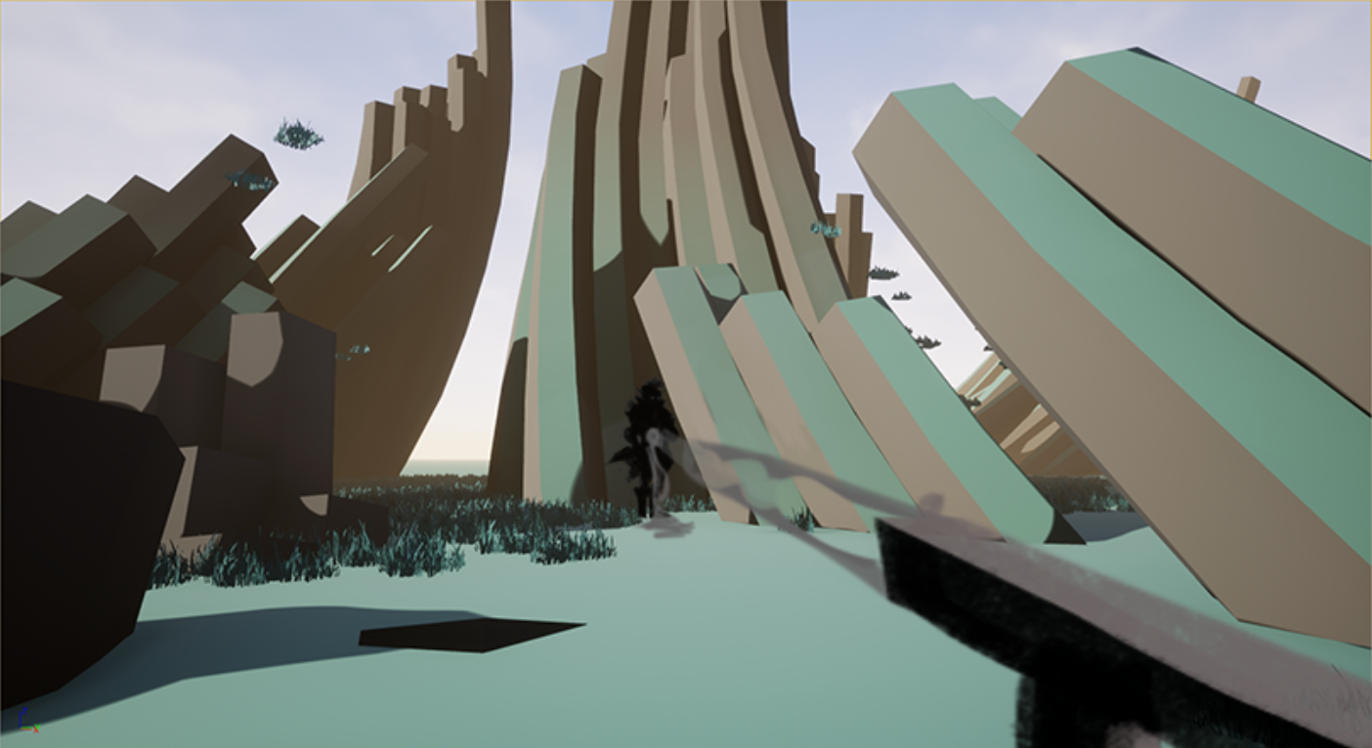
What is it: Time machine? that speeds up time at the point
How it causes damage: Decomposition overtime, turning into dust
What’s the cooldown: Power source capacity (battery, crystal?)
What are the modules: Watch mechanisms?

Blood, magnetically propelled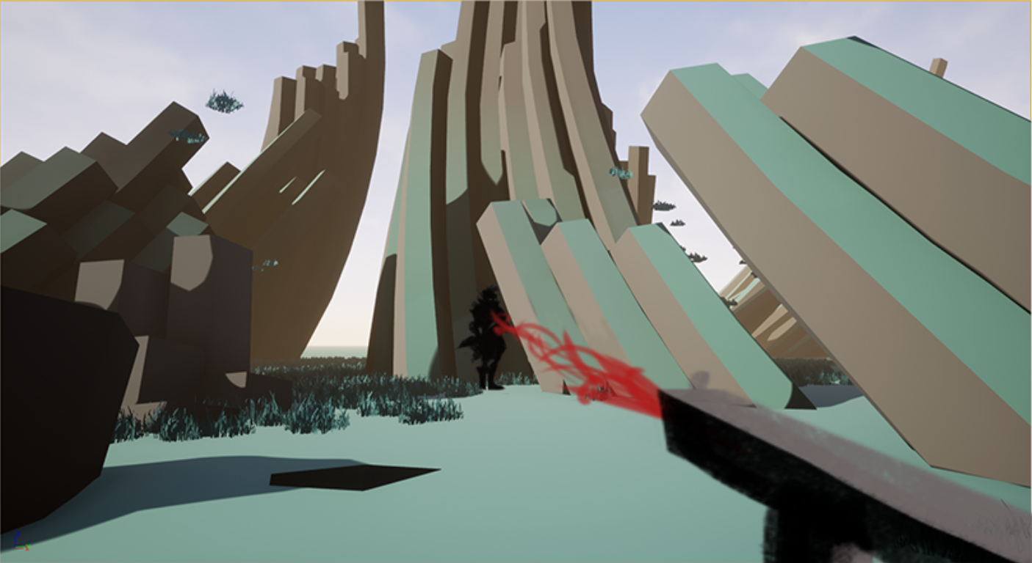
What is it: Railgun that uses your blood as ammunition
How it causes damage: Impact? Poisonous/corrosive to this planet's organisms?
What’s the cooldown: User getting sucked dry
What are the modules: Tubes, needles, filters, magnets

Sucking out something out of the enemy, for example, minerals
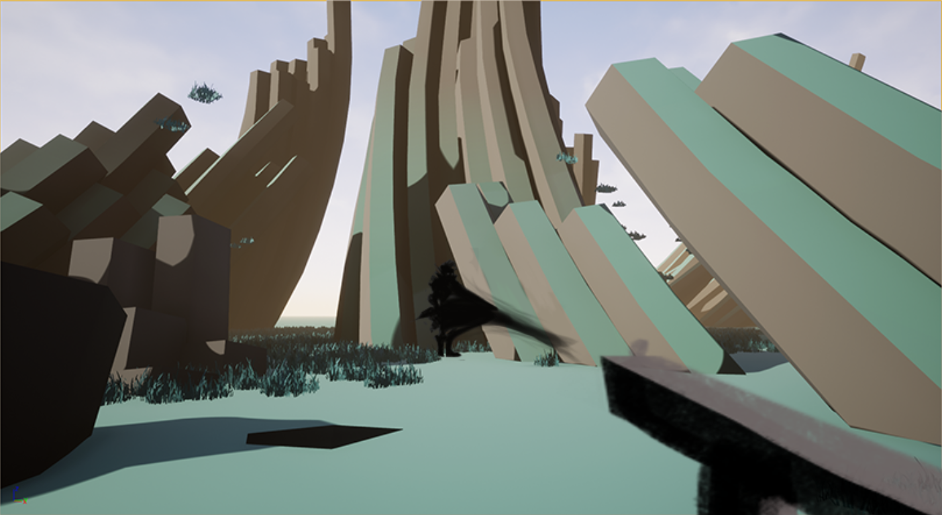
What is it: A boosted vacuum? that extracts resources out of the enemies
How it causes damage: Decomposition, deconstruction
What’s the cooldown: Getting full
What are the modules: Pumps, tubes, nozzles

Design feedback/analysis
Picked design - Laser

Reference for a Laser gun

Feature tech
To be filled in by the programmer
The goal of this Tech part is to describe all external dependencies and public interfaces of this feature. Create 1 file which contains all the diagrams in different tabs. Put it in this folder:

Class Diagram
Create a diagram describing what classes you’ll create, their inheritance, what functionality they are responsible for, and what variables they expose as ‘tweakable’ or public. Also, specify which classes will be data-only children and can be edited by designers.

Interactions
Describe how the feature will interact with other parts of the game. Also consider requirements of assets (for example timings in animations, collision boxes).

Network
If applicable, add a networking sequence diagram.

Requirements
Art
Describe Art requirements here

Audio
Describe Art requirements here

Level Design
Describe Art requirements here

QA questions
Add link to prototype proposal
Prototype proposal from page 6 onwards(Visual Grid)

Resources
Link to documents about this feature/research
Inventory Design Research
UI/UX Research

