The tool
Team 2 survival game
‘This document contains the details on the resource collection with the tool.’

CHANGELOG
No. | Date | Developer | Description
001 | 20/12/18 | Dana van der wal | Basics of the tool
002

Functionality
The tool can mine resources of any kind. To mine these resources the tool need destroy the object. After destroying the object the resources go directly into the players inventory.

The tool is a continuous laser.
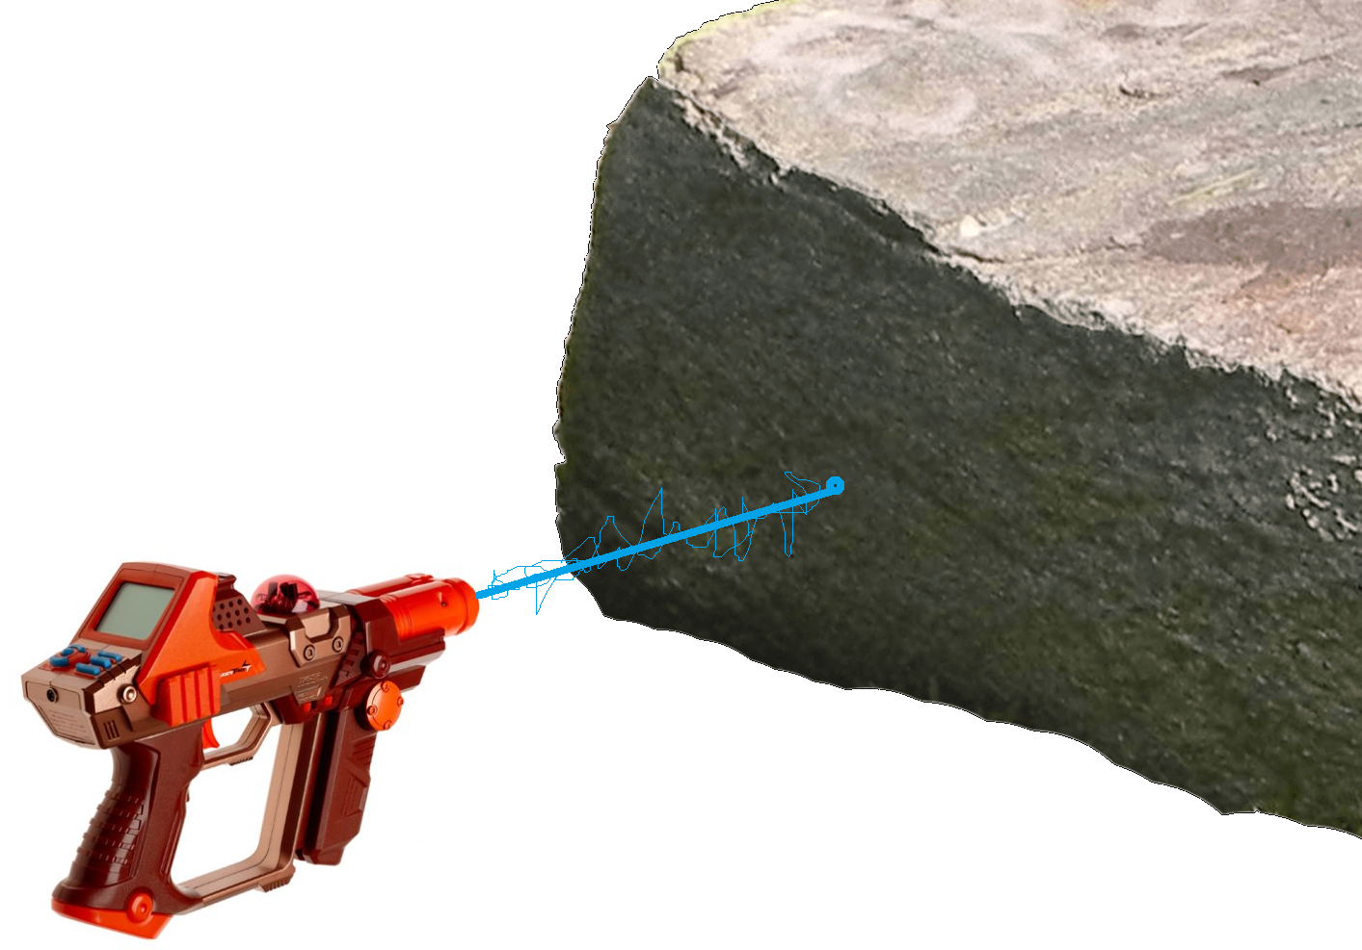
If the laser does enough damage to the rock, the rock will explode and the player gets the resource.
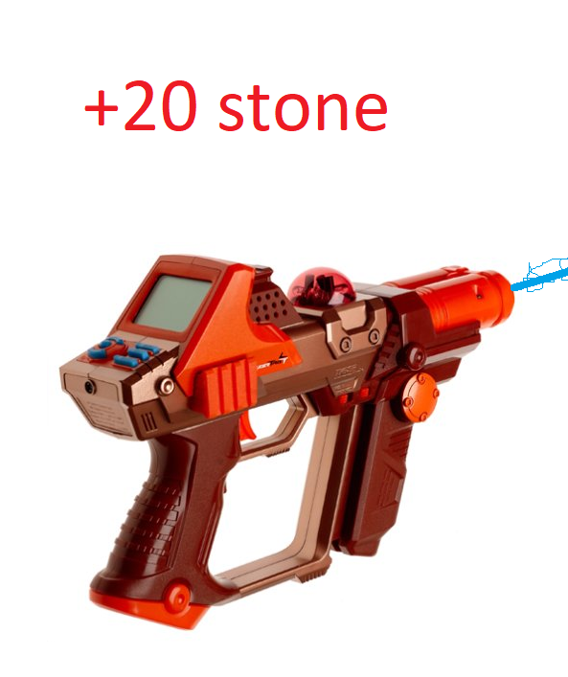

Minigame:
On each resource there is a pattern. These patterns are the weak points of the resource pile.
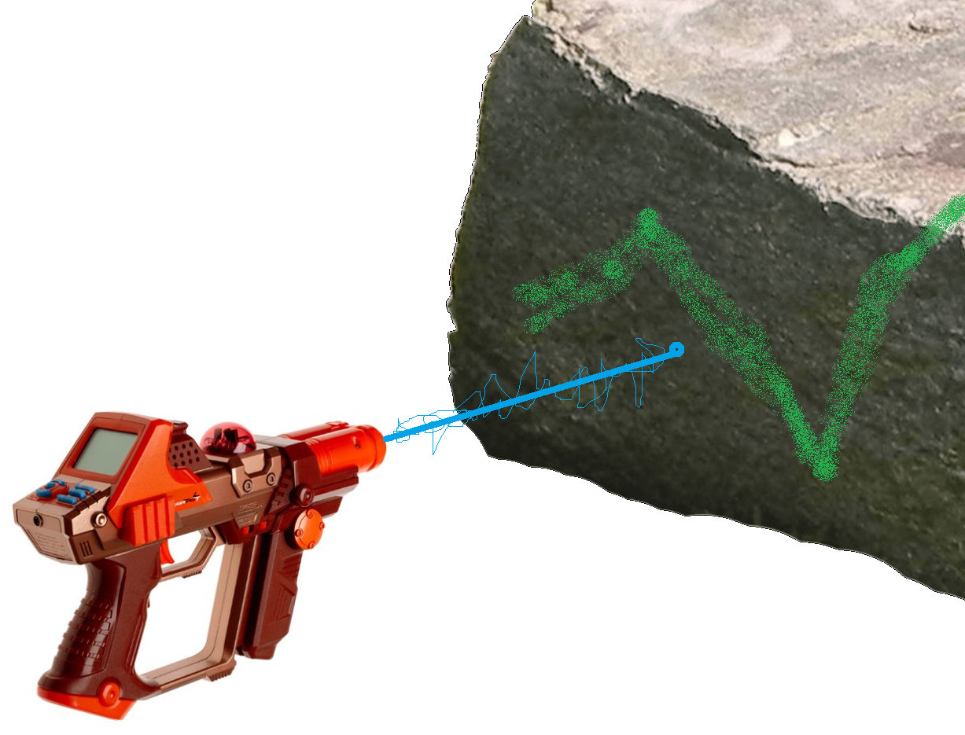
If the player follows this pattern with their laser than they will Mine the resource faster. (the resource pile will be destroyed quicker.)
They will also get a bonus resources if they complete the pattern. If a pattern is completed the resource pile should be destroyed.

